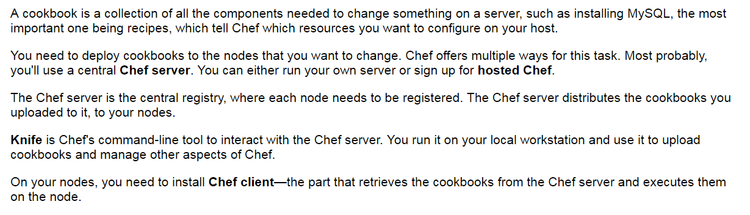

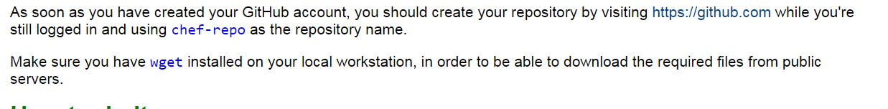

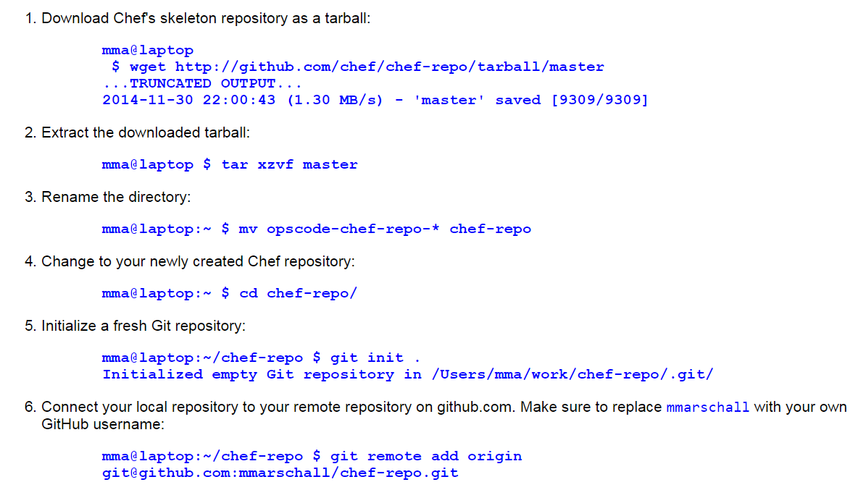

cher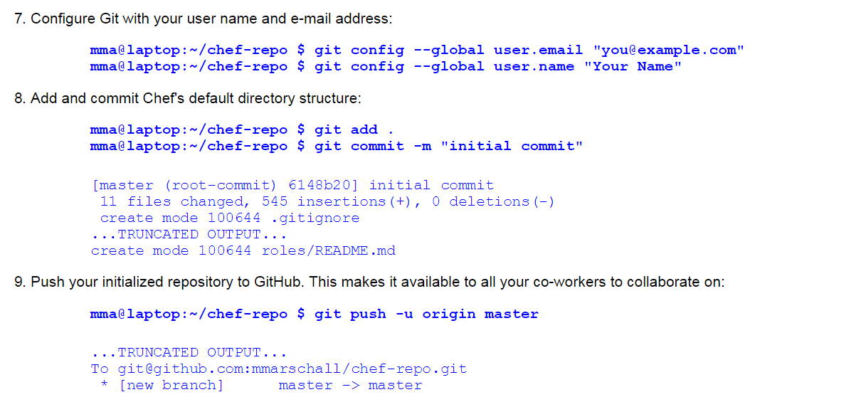

Chef repo and connected it to your own repository on GitHub

**mma@laptop:~/chef-repo $ git pull --rebase**

**see also vedios Git basics at** [**http://git-scm.com/videos**](http://git-scm.com/videos)

**or** [**https://help.github.com/categories/54/articles**](https://help.github.com/categories/54/articles)

**Installing the Chef Development kit on your workstation first** then you’ll have to develop your configurations locally and use chef to distribute them to your chef server

Chef is fully packed version no external prerequisites hence called omnibus installer

To verify chef installed all components

~$ chef verify

Add the newly installed ruby to your path

~$ echo ‘export PATH=”/opt/chefdk/embedded/bin:$PATH”’ >> ~/.bash_profile && source ~/.bash_profile

Omnibus will download all required ruby gems into /opt/chefdk

See also <https://learn.chef.io>

Find chefDK on GitHub at <https://github.com/opscode/chef-dk>

**Using the hosted chef platform**

Get started with chef right away without the need to install your own chef server is hosted chef platform

<http://manage.chef.io/signup> and register for free trial or a free account

I registered as the user webops and with an organization short name of awo

How to do it….

Carry out the following steps in order to interact with hosted chef

1. ~$ ~/chef-repo $ mkdir .chef
2. Navigate the <http://manage/chef.io/organizations> after logging in , you can start downloading your validation keys and configuration file.
3. Select your organization to be able to see its contents using the web UI, regenerate the validation key your organization and save it as <your-organization-short-name>-validator.pem in the chef directory inside your chef-repo repository.
4. Generate the knife config and put the download knife.rb into the .chef directory inside your chef-repo directory as well. Make sure you have downloaded your user’s private key from <https://www.chef.io/account/password> and replace webops with username you chose for the hosted chef and awo with the short name you chose for your organization 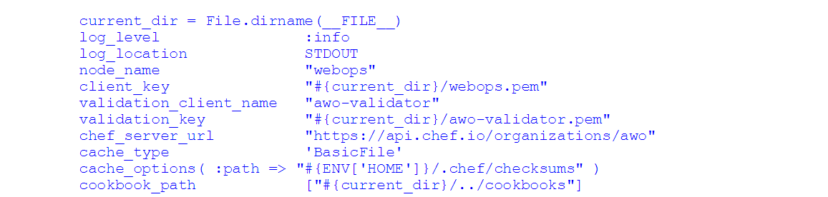

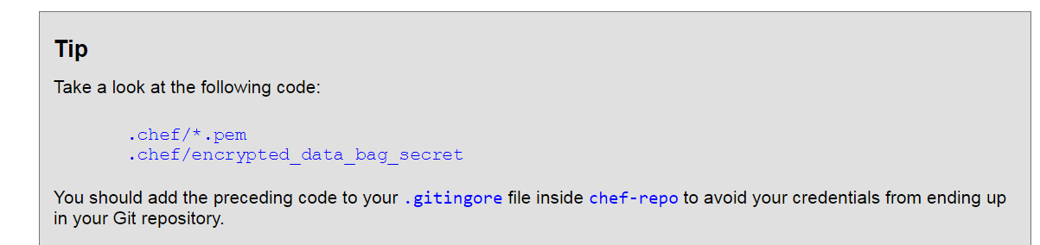

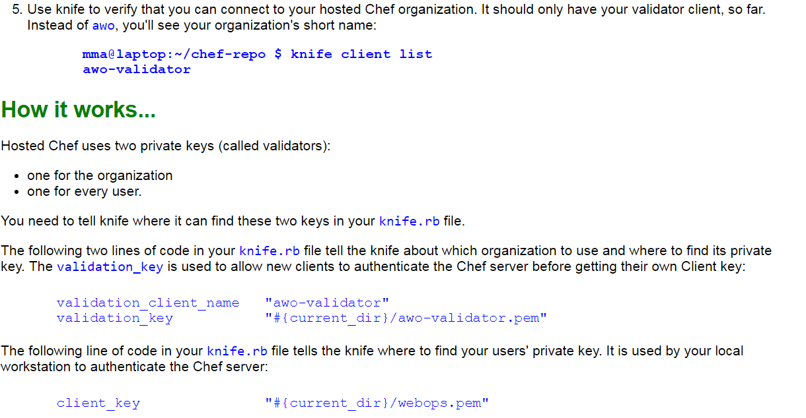

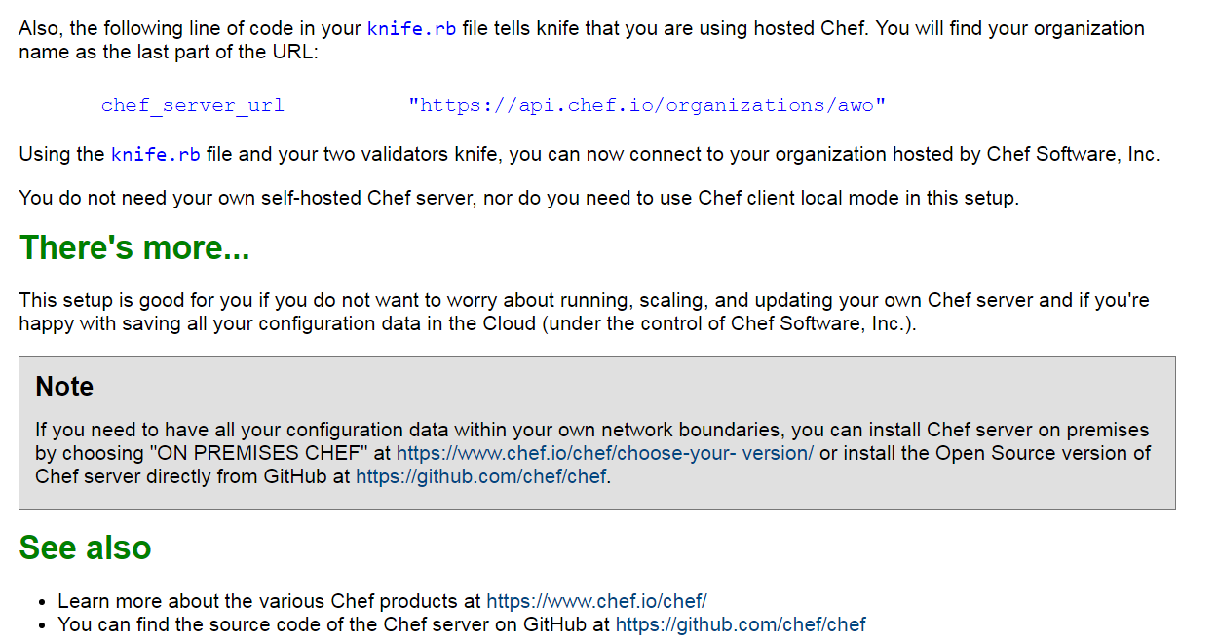

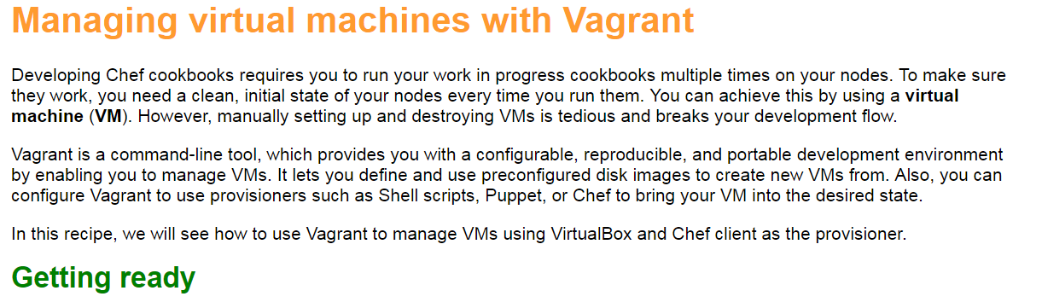

Download and install virtualbox at <https://www.virtualbox.org/wiki/Downloads>.

Download and install Vagrant at <https://www.vagrantup.com/downloads.html>

Install the omnibus vagrant plugin to enable vagrant to install the chef client onyour vm by running the following command

~$ ~/chef-repo $ vagrant plugin install vagrant-omnibus

Installing the ‘vagrant-omnibus’ plugin. This can take a few minutes….

How to do it…

Lets create and boot a virtual node by using vagrant

Visit <https://githun.com/opscode/bento> and choose a vagrant box to base your VMs on we’ll use opscode-ubuntu-14.10 in this example

The url of the opscode-ubuntu-14.10 box is <https://opscode-vm-bento.s3.amazonaws.com/vagrant/virtualbox/opscode_ubuntu-14.10_chef-provisionerless.box>

Edit your new vagrantfile. Make sure that you replace <your - org> with the name of your organization on the chef server.use the name and url of the box file you noted down in the first step as config.vm.box and config.vm.box_url:

~$ ~/chef-repo $ subl Vagrantfile

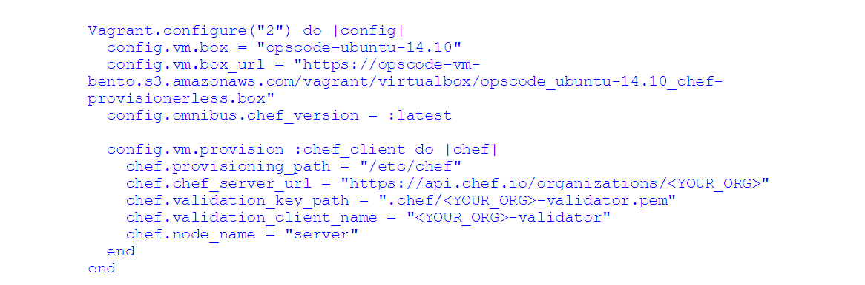

Create your virtual node using vagrant

~$ ~/chef-repo $ vagrant up

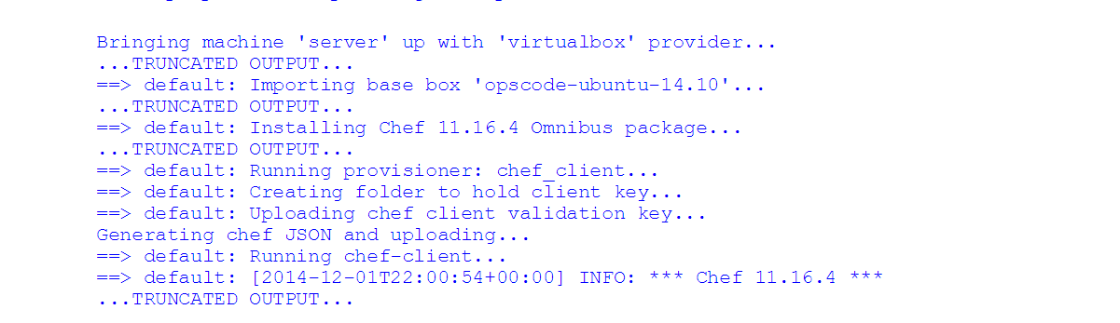

Log into your virtual node using ssh

~$ ~/chef-repo $ vagrant ssh

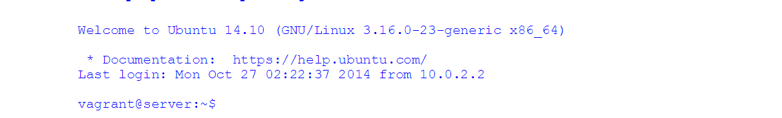

Log out of your virtual node:

vagrant@server:$ exit

~$

Validate that the chef server knows your new virtual machine as a client called server

~$ ~/chef-repo $ knife client list

Go to [https://manager.chef.io/organizations/<YOUR](https://manager.chef.io/organizations/%3cYOUR) ORGANIZATION>/ nodes and validate that your new VM shows up as a registered node

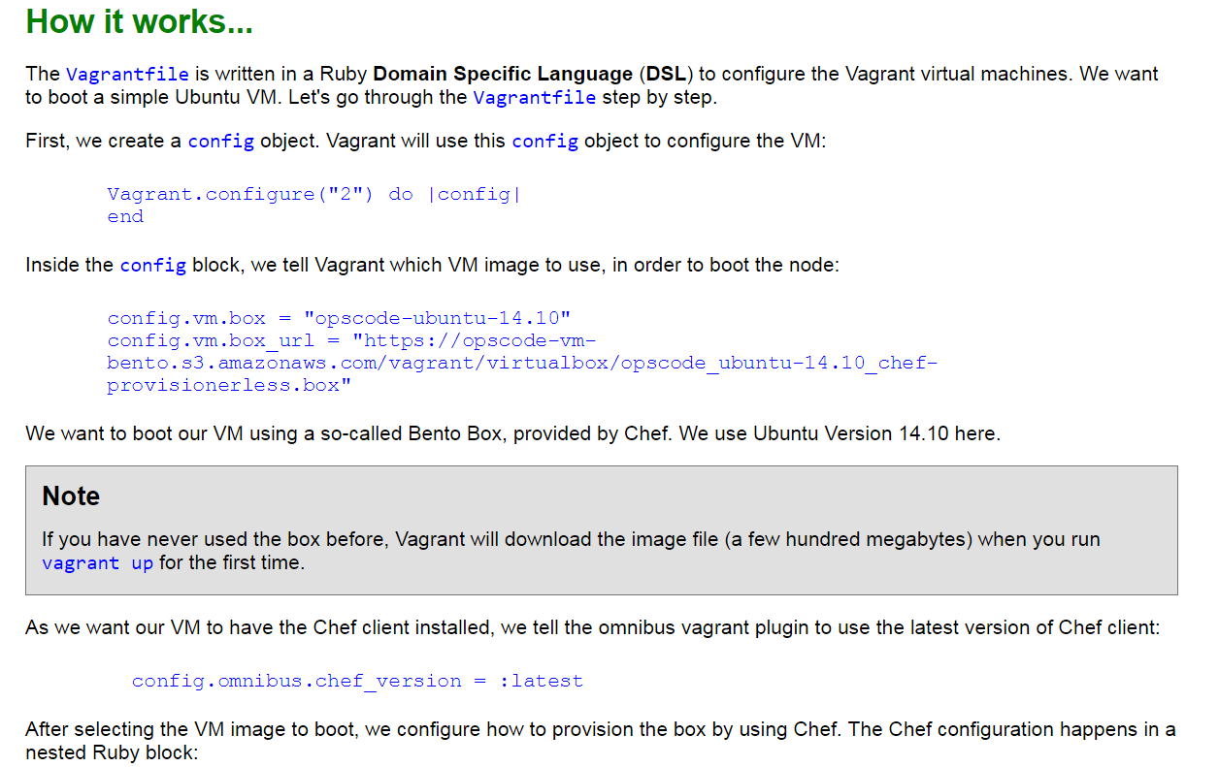

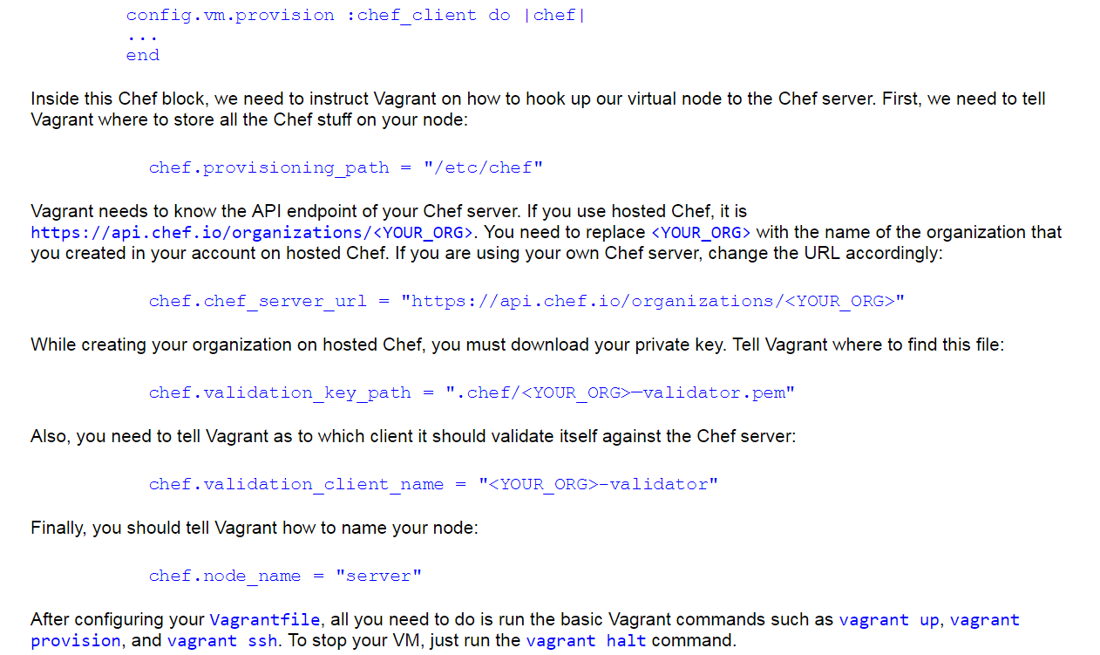

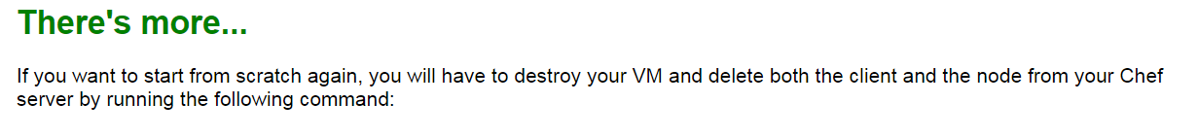

~$ ~/chef-repo $ vagrant destroy

~$ ~/chef-repo $ knife node delete server –y && knife client delete server –y

Alternatively you may use vagrant butcher plugin found at <https://github.com/cassianoleal/vagrant-butcher>.

See also

Vagrant documentation at <http://docs.vagrantup.com/v2/getting-started/index.html>

Vagrant plugin for VMware instead of Virtualbox and find it at <http://www.vagrantup.com/vmware>

You can use vagrant plugin for amazon AWS of virtualbox and find the same at <https://github.com/mitchellh/vagrant-aws>

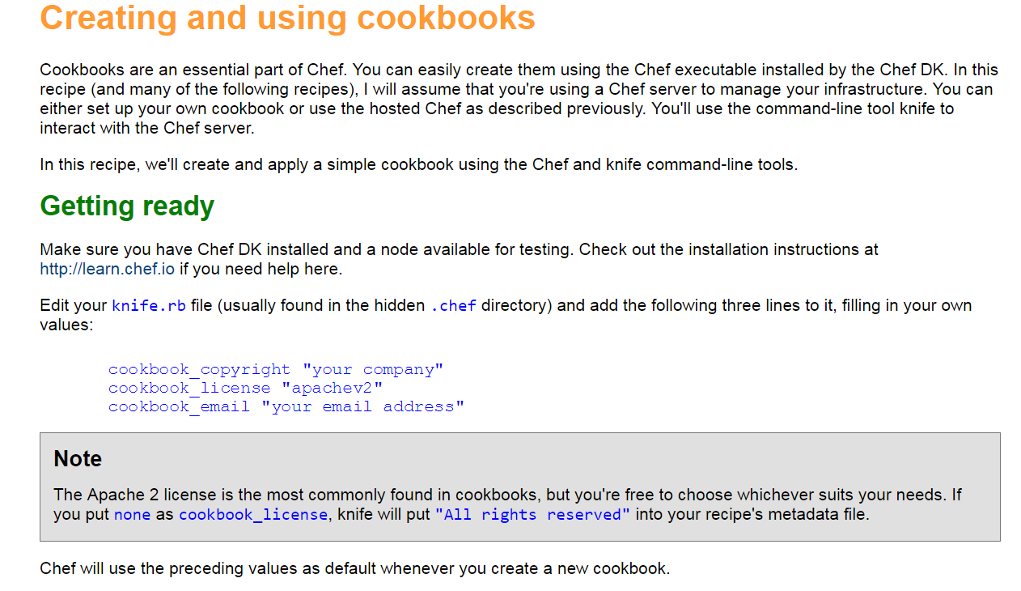

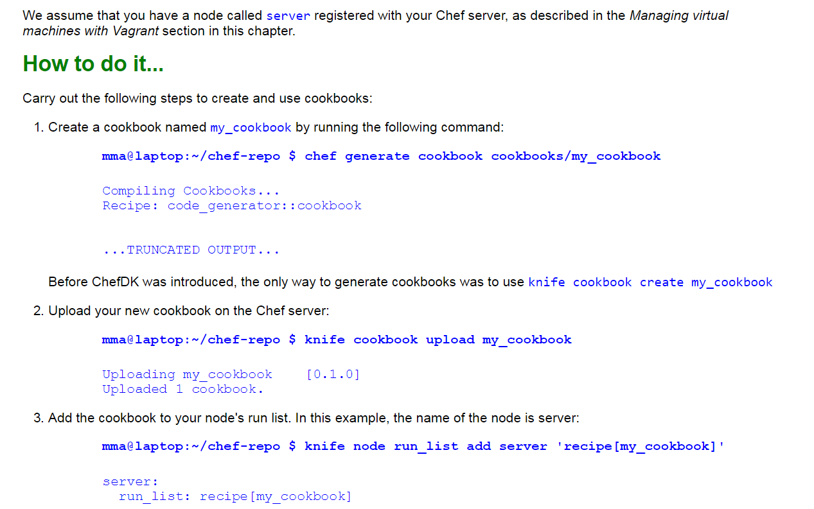

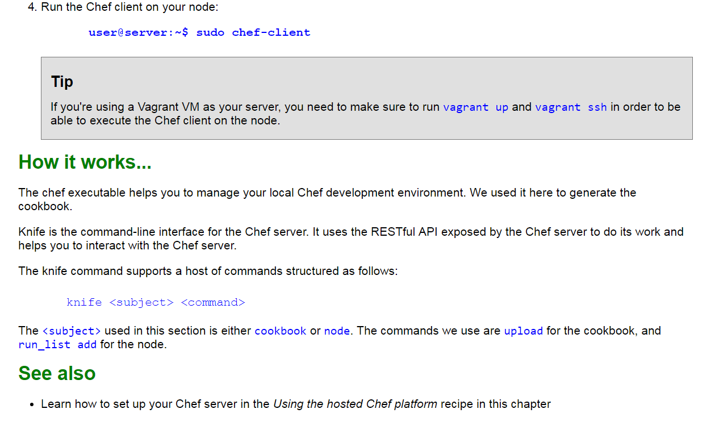

**Commands from above Creating and using cookbooks**

mma@laptop :~ /chef-repo $ chef generate cookbook cookbook/my_cookbook

upload your new cookbook

mma@lapton:~/chef-repo $ knife node run_list add server ‘recipe[my_cookbook]’

server:

run_list : recipe[my_cookbook]

run the chef client on your node

user@server:~$ sudo chef-client

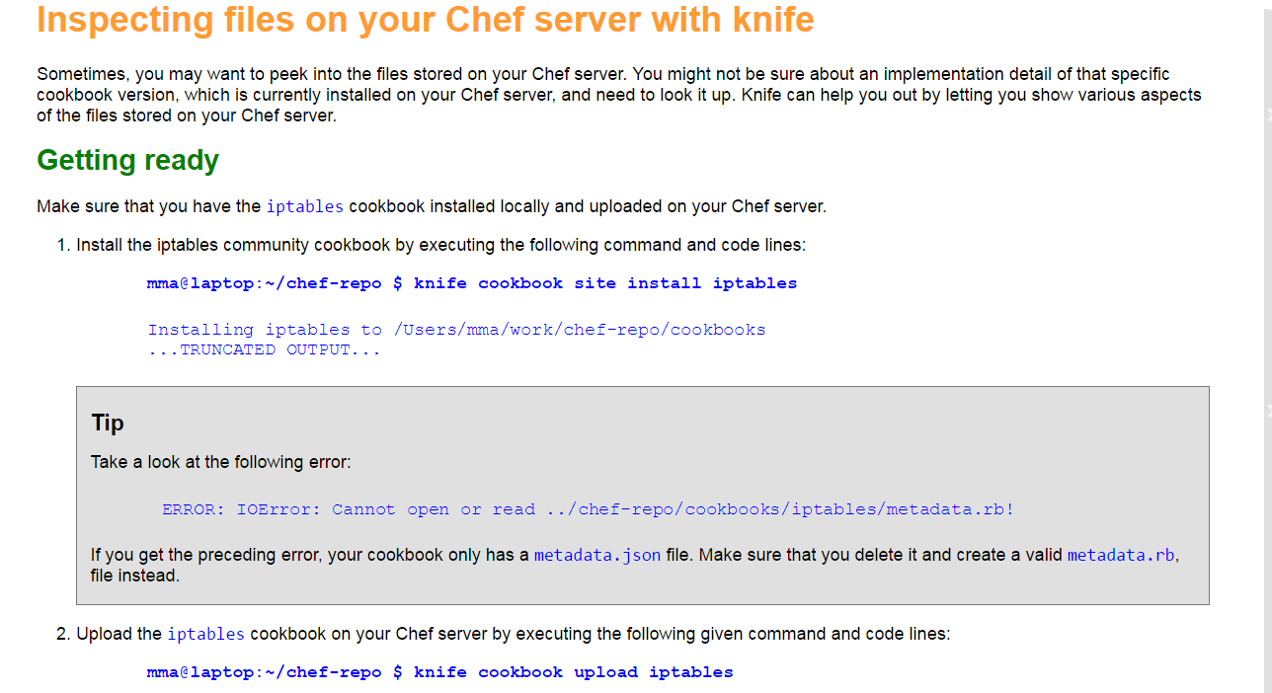

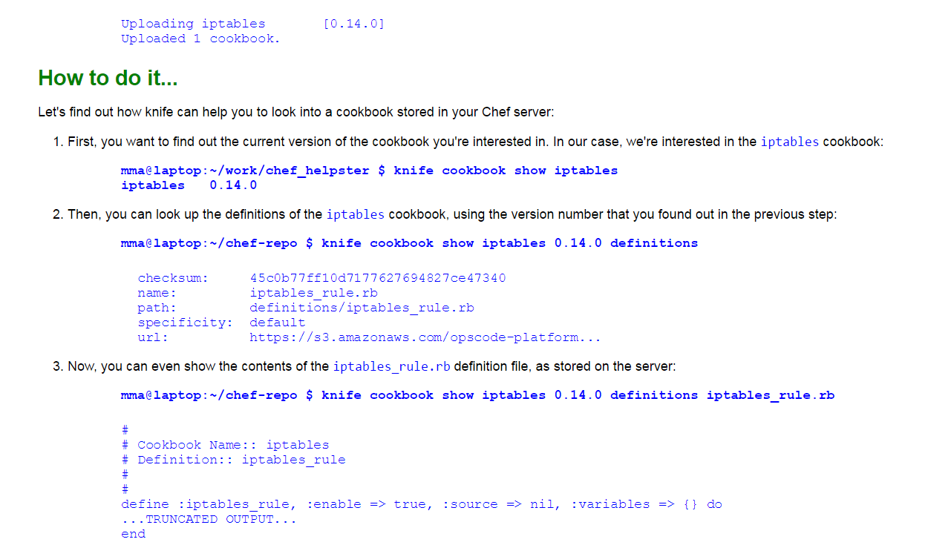

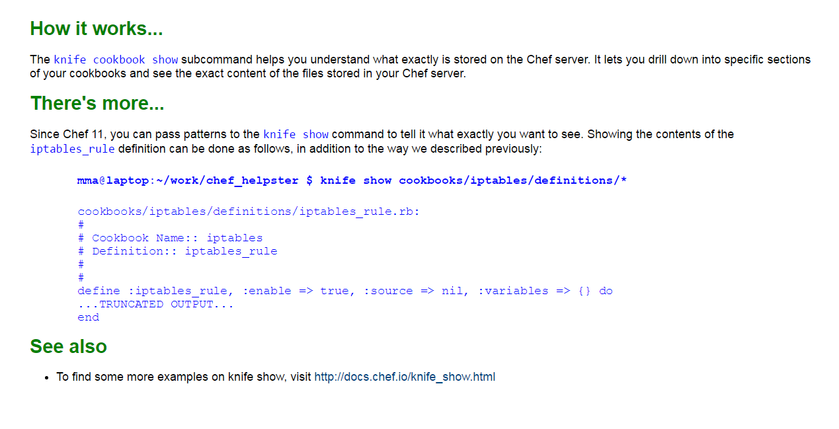

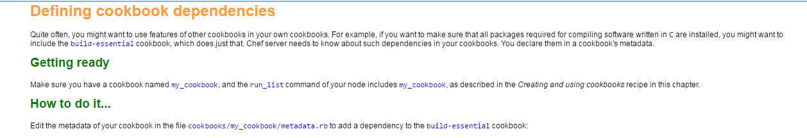

mma@laptop :~/chef-repo $ subl cookbooks/my_cookbook/metadata.rb



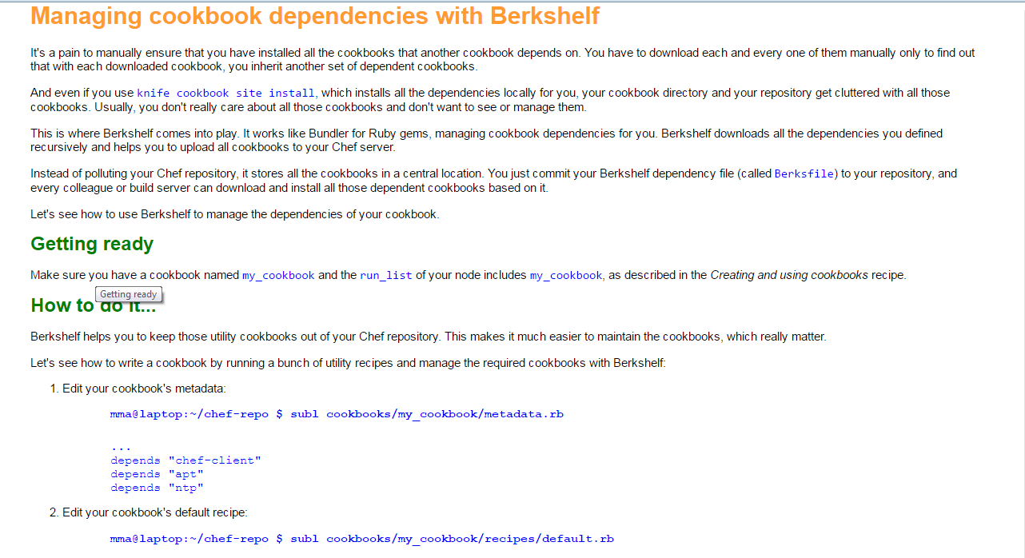

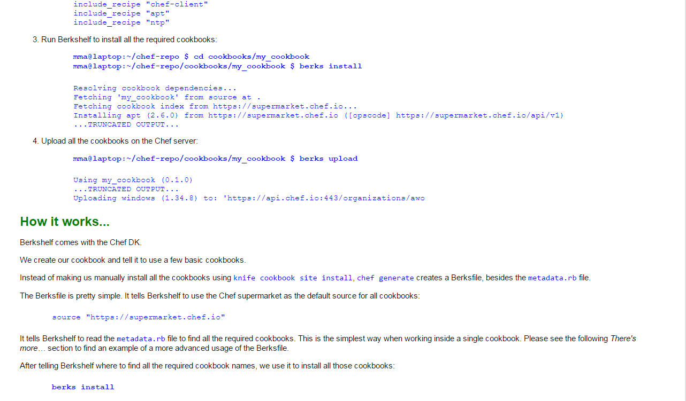

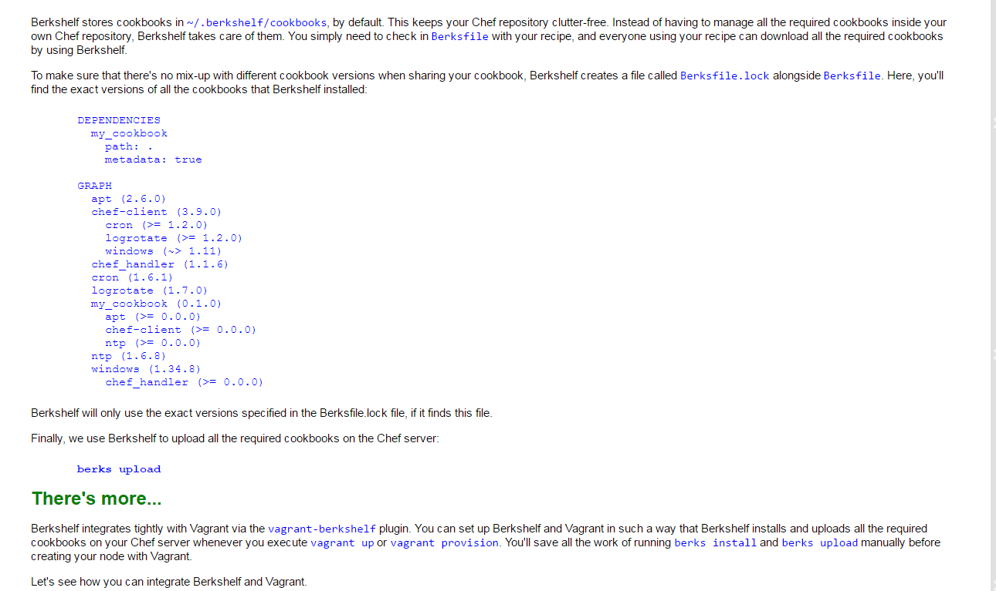

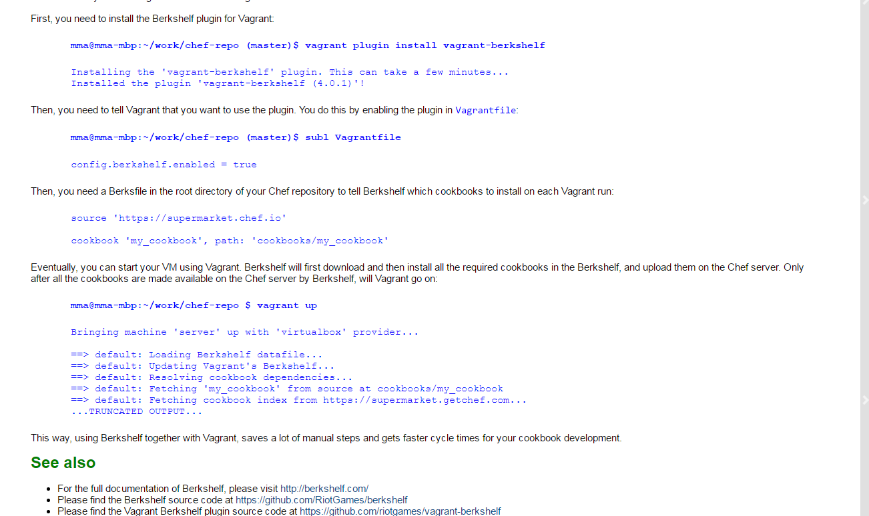

mma@laptop: ~/chef-repo $ subl cookbooks/my_cookbook/metadata.rb

mma@lapton:~/chef-repo $ subl cookbooks/my_cookbook/receipes/default.rb

mma@laptop:~/chef-repo $ cd cookbooks/my_cookbook

mma@lapton:~/chef-repo/cookbooks/my_cookbook $ berks install

mma@lapton:~/chef-repo/cookbooks/my_cookbook $ berks upload

mma@lapton:~/chef-repo/ (master)$ vagrant plugin install vagrant-berkshelf

mma@lapton:~/chef-repo (master) $ subl Vagrantfile

mma@mma-mbp:~/work/chef-repo $ vagrant up

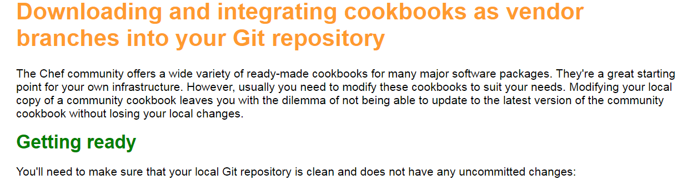

mma@laptop:~ /chef-repo $ git status

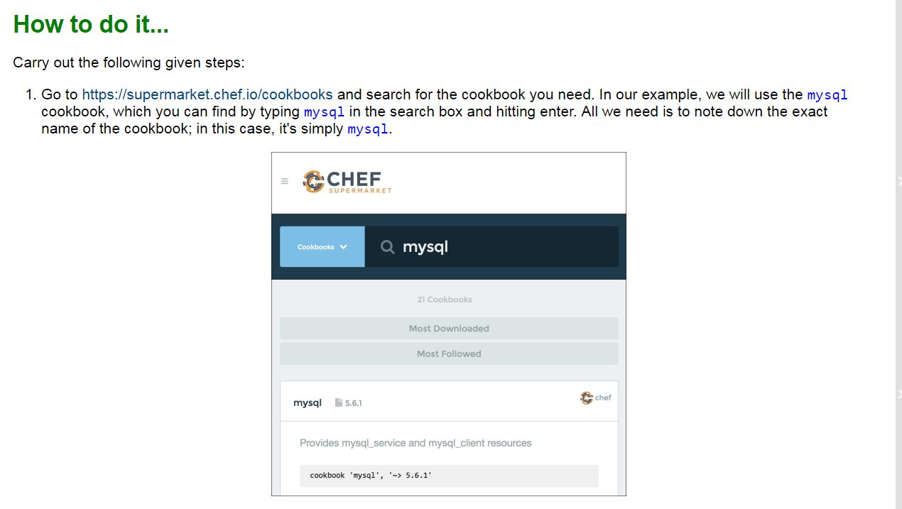

mma@laptop:~/chef-repo $ git status

mma@laptop:~/chef-repo $ knife cookbook site install mysql

mma@laptop:~/chef-repo $ cd cookbooks

mma@lapton:~/chef-repo/cookbooks $ ls -l

mma@laptop:~/chef-repo/cookbooks $ git status

mma@laptop:~/chef-repo/cookbooks $ git log

mma@laptop:~/chef-repo $ git branch -a

mma@laptop:~/chef-repo [experiemental] $ knife cookbook site install mysql –branch experimental

mma@laptop:~/chef-repo [experiemental] $ knife cookbook site install mysql –D

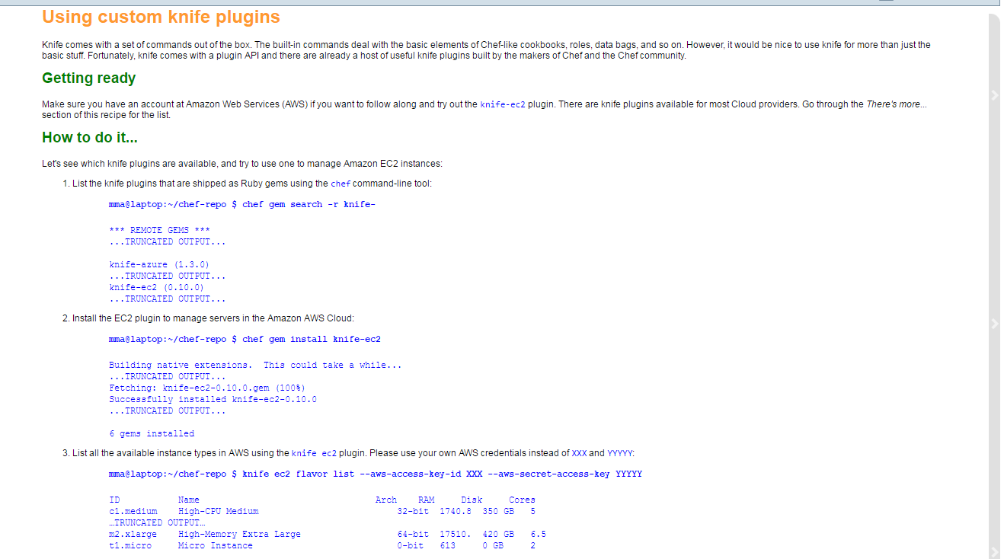

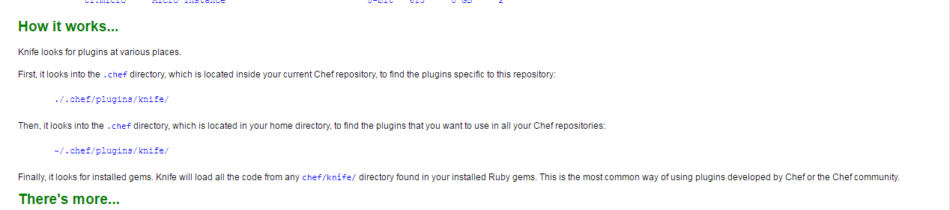

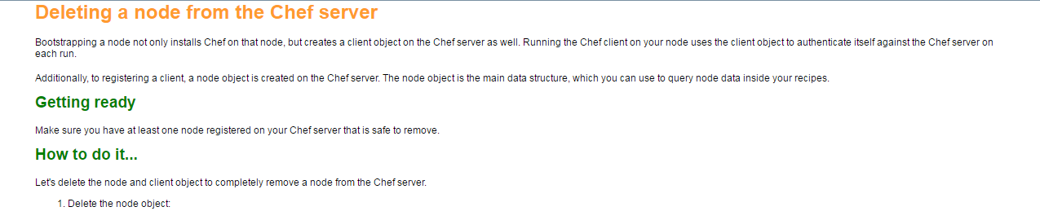

mma@laptop:~/chef-repo $ knife node delete my_node

2. Delete the client object:

mma@laptop:~/chef-repo $ knife client delete my_node

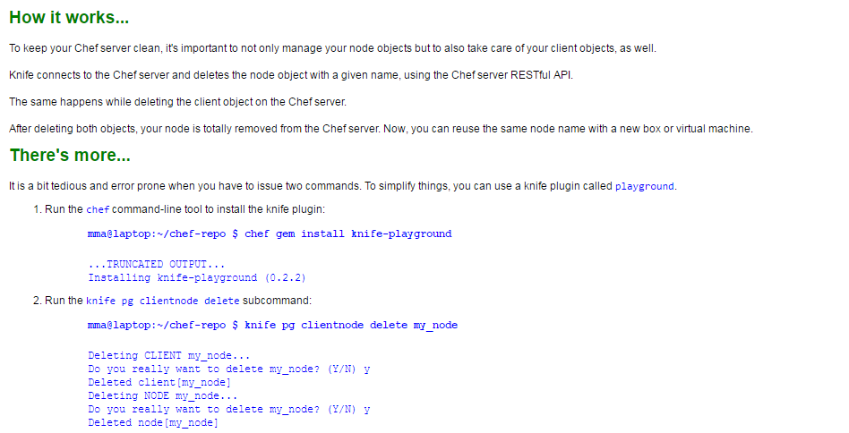

mma@laptop:~/chef-repo $ chef gem install knife-playground

mma@laptop:~/chef-repo $ knife pg clientnode delete my_node